  
CSC 1501 INTRODUCTION TO SOFTWARE ENGINEERING

PROJECT REPORT   
for

**Online Islamic Books Rental System**

Prepared by:

|  |  |  |
| --- | --- | --- |
| 1. MD. Afique Amin Zian. | 1631005 | [afiquezian@gmail.com](mailto:afiquezian@gmail.com) |
|  |  |  |
| 1. Nasik Sami Khan. | 1638153 | [nasiksami@gmail.com](mailto:nasiksami@gmail.com) |
| 1. Md. Sariful Islam. | 1626667 | [sarif2435@gmail.com](mailto:sarif2435@gmail.com) |
| 1. Yahia Siddique. | 1639835 | yahiasid3@gmail.com |
|  |  |  |
|  |  |  |
|  |  |  |

Prepared for:  
Lecturer: Imam sir  
Section: 06  
 Date of submission:19/12/17

**Table of Contents**

1 Introduction 1

1.1 Document Purpose 1

1.2 Project Scope 1

1.3 Intended Audience and Document Overview 1

1.4 Definitions, Acronyms and Abbreviations 1

1.5 References and Acknowledgments 1

2 Overall Description 2

2.1 Project Perspective 2

2.2 Users and Characteristics 2

2.3 Design and Implementation Constraints 2

2.4 Assumptions and Dependencies 2

3 Software Process Model 4

3.1 Software Process Model 4

4 Requirements Phase 5

4.1 Requirements Engineering activities 5

4.2 Scope Definition and Problem Analysis 5

4.3 Requirements Analysis 5

5 Design Phase 7

5.1 Design activities 7

6 Testing Phase 9

6.1 Testing activities 9

7 Implementation Phase 10

7.1 Implementation activities 10

# Introduction

Online Islamic books rental system– This system is developed to help people to find Islamic books per their choices. Since different people have different books preferences, we perform careful feature selection to take advantage of the information reflected in the system user’s reviews. Furthermore, since renting is frequently a communal activity, we generated recommendations not just for an individual user, but also for a group of users. This system needs to consider the information of all individuals in a group and recommend books that satisfies the group of users according to some criterion.

## Document Purpose

The purpose of this document is to describe the use, operation, maintenance, or design of software or hardware using manuals, listings, diagrams, and other materials.

## Project scope

The purpose of the software as mentioned before is to make things easier for people to choose Islamic books. People have different books tastes and criteria. According to their choices, there will be different categories to choose which types of Islamic books he or she wants to take.

It will not only save the time of customers but also help them to maintain a proper management to enhance your study . Moreover, for groups like the students of IIUM, UM, UTM also can access to this website for renting their study purpose Islamic books.

## Intended Audience and document overview:

This website is designed for mainly the people who wants more knowledge about islam. And also for those who is a book worm. This categories of people can read Islamic books to enhance their knowledge of Islam.

## Definitions, Acronyms and Abbreviations

IIUM = International Islamic University Malaysia

UM = University of Malaya

UTM = University Technology Malaysia

## References and Acknowledgments

1. [http://www.academia.edu/4413692/Location_Based_Personalized_library _Recommendation_System_for_Mobile_Environments](http://www.academia.edu/4413692/Location_Based_Personalized_library%20_Recommendation_System_for_Mobile_Environments)
2. <http://ieeexplore.ieee.org/document/7324140/>
3. <http://blog.nycdatascience.com/student-works/library-recommendations-groups-people/>
4. Android <http://developer.android.com>
5. IOS Xcode, <https://developer.apple.com/xcode/>
6. Zxing. <http://code.google.com/p/zxing/>
7. Sommerville, Software Engineering, Tenth edition
8. <http://www.academia.edu/4413692/Location_Based_Personalized_libraryt_Recommendation_System_for_Mobile_Environments>
9. <http://ieeexplore.ieee.org/document/7324140/>
10. <http://blog.nycdatascience.com/student-works/library-recommendations-groups-people/>

# Product Description

## Product Overview

This project will focus on a new self-contained product as this software hasn’t been developed before/any content of this software hasn’t been inherited. It was purely based on the requirements we gathered and we made sure that the software was engineered to meet our customers’ demands. However, the idea of this project is generated through public interest.

This program can be accessed by both pc and mobile phones, however we focused more on the mobile part to make the software more portable and easy to use since every customer carries a phone with them and not necessarily carries a laptop around with them. Hence, having a smart phone is a one of the major requirements for the software to work. Furthermore, to control the system another major component of this system would be the system administrator and user who will use it. The system will constantly be updated through users review which will maintained buy the admin.

## Product Functionality

The major functionalities of this system are:

1. Give people a feedback about the Islamic books which he or she can read.
2. Categorization for diverse types of books. Like Hadiath, Quran, Ramadan etc.
3. There will also be prices and description of the books.
4. People can rate and submit their opinion about the service..

## Users and Characteristics

This product will mainly be used by two categories of users. Nevertheless, the privilege levels and importance will be explained.

* Enforcement Staffs – Staffs who roam around libraries to mark books and will categorize those books according to category types etc. and upload books names.

* System Maintainer – A maintainer who manages the all the administrator from different sections and allocates them different tasks under different situations, He is more experienced than a regular admin. If there is any problem occurred in the system, he will handle it properly.

## Design and Implementation Constraints

* Time – not enough time is given to us by the client to develop the software
* Flexibility – Although it has been made flexible, all users may not have the right privilege to use the application.
* Money – the budget provided may not be enough to meet the project requirements thus it was hard to work with the limited amount of budget we were allocated for it

## Assumptions and Dependencies

This project takes the following factors into assumption for the software to work

* All staffs have sufficient knowledge on how the system works.
* All working people in this system must have a smartphone capable of running the software
* All staffs don’t have the privilege to change the system without the permission of System maintainer.

**3.Software Process Model**

**3.1 Software Process Model (Prototype):**

The Prototyping Process Model is a method in which a prototype (an early approximation of a final system or product) is built, tested, and then reworked as necessary until an acceptable prototype is finally achieved from which the complete system can now be developed. This model works best in scenarios where not all of the project requirements are known in detail ahead of time. It is an iterative, trial-and-error process that takes place between the developers and the users. If a working prototype is to be built, you can make use of existing program fragments or apply tools (e.g., report generators and window managers) that enable working programs to be generated quickly.

This sort of process model is best suitable when the system that is planned needs to have a lot of end-user interactions such as Online Systems, Web Interfaces etc. This process model ensures that the end users are constantly in touch with the systems and provides feedback which is then integrated into the prototype making it into a more useable system with better features.

## Taking this process model in to our project followed the following steps to guide us while we use the model:

1. Define system requirements: Conduct survey and collect the requirements needed for the project.

2. Create a preliminary design: based on the requirements we have gathered we make a preliminary design for the software concept.

3. Construct initial prototype : and then based on the design we build our first prototype for evaluation.

4. User Evaluation: we test the first prototype with members of the user’s of the Library and collect their feedback.

5. Modification : based on the evaluation we make necessary changes and repeat the whole process.

6.Final Deployment : once all the requirements are met and final evaluation is satisfactory we deploy the software for the customers to use.

**3.3 Activities Involve:**

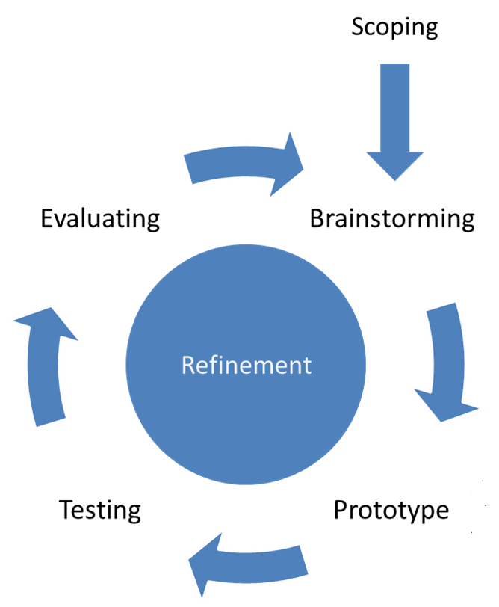

**Figure: Protoype Process Model**

**(Islamic Book Rental System)**

• The new system requirements are defined in as much detail as possible. This usually involves interviewing several staffs representing maintenance of the system and also take opinion of customers or users.

• A preliminary design is created for the new system based on the results of the interviews.

• A first prototype of the new system is constructed from the preliminary design. This is usually a scaled-down system, and represents an approximation of the characteristics of the final product.

• The staffs thoroughly evaluate the first prototype, noting its strengths and weaknesses, what needs to be added, and what should to be removed, after which we collect and analyze the remarks from the staffs. This is done by allowing a few staffs to carry out the basic functionalities of the application at first, i.e. Reviews of books, categorization of different generation , author , publications etc.

• The first prototype is modified, based on the comments supplied by the users, and a second prototype of the new system is then constructed.

• The second prototype is evaluated in the same manner as was the first prototype.

• The preceding steps are iterated as many times as necessary, until the customers or users are satisfied that the prototype represents the final system desired.

• The final system is constructed, based on the final prototype.

• The final system is thoroughly evaluated and tested. Routine maintenance is carried out on a continuing basis to prevent large-scale failures and to minimize downtime. Once the software is ready, it is deployed for usage among all the customers or users.

**4 .Requirement Phase**

## 4.1: Requirements Engineering activities:

**Inception:**

|  |  |  |  |
| --- | --- | --- | --- |
| **Actors** | **Task-level-goal** | **priority** | **Brief** |
| Students without membership | Ask for membership, Renting books and Information | High | Firstly the person must enter his email id and mention library id and password .By doing this he/she will be a member. |
| visitor | Checking information, benefits of this app, and processing of membership | medium | Here the system will allow the visitor to know about this app and the way to get books. |
| Student with membership | To search and rent books, gathering information of that desired books. | High | The student will type the book name in the search engine and the system will find gather relevant topics from the systems and renting information or history from the system’s database. |

● **Elicitation:**

1. The​ ​techniques​ ​that​ ​we​ ​have​ ​used​ ​are​ ​:

- moqups

- wix

- Ms​ ​word

- Ms​ ​Docs

2. The​ ​comparison​ ​of​ ​our​ ​website​ ​with​ ​ physical ​library is our​ ​website​ ​is​ ​quite​ ​similar​ ​with​ ​ any ​library​ ​in​ ​terms​ ​of​ ​features​ ​but for having a book from a physical library u have to present physically and use your membership card to get the desired books. If u choose online renting system u don’t need to present physically to rent a books. So u can do it through our website easily.

● Elaboration

The​ ​main​ ​use​ ​case​ ​of​ ​our​ ​project​ ​is​ ​to​ use online for renting a book for a certain period.

## 4.2 Scope Definition & Problem Analysis:

The problem regarding this application is the reviews of customers. Because every person has different choices of books and they may not be loyal giving their opinion. Every error can result in a potential loss and mislead other customers which impacts our system and people won’t trust the system anymore. To increase the accuracy and avoid such problems is the reason why this project is undertaken as the problem here could lead to profound consequences, especially when there are financial matters involved.

## 4.3 Requirement Analysis:

### 4.3.1 Functional Requirements:

* Track the location of customer through GPS.
* Capture the ratings & reviews given by the customers.
* Able to capture pictures of the book cover.

* Able to categorize books according to regions, authors, genres, publications etc.
* Description of books and their availability and renting details .

### Activity Diagram:

Check Availability

Enter your borrow date and return back date

Available

Do u want to continue?

No match found

Already Rented

Check Availability

**4.3.2 Use Case Diagram:**

**Admin**

**Customer**

### 4.3.3 Use Case Narratives:

|  |  |  |  |  |
| --- | --- | --- | --- | --- |
| Use Case Identification and History | | | | |
| **Use Case ID:** | A.B.C 123 | | | |
| **Use Case Name:** | Search for Books | | **Version No:** |  |
| **End Objective:** | Rent the desired books. | | | |
| **Action:** | **User** | **System** | | |
|  | 1. Tap the welcome button | 1. Give user the access to enter the system | | |
|  | 1. Tap the search button and type in the text field | 1. Search and give the result to user. | | |
| **Business Owner Name:** | Mr. Ahmed | | **Contact Details:** | 01XXXXXXXX |
| **Trigger:** |  | | | |
| **Frequency of Use:** | **Rapidly** | | | |

| Exception Flow | | |
| --- | --- | --- |
| 1 | Type a book name that does not match available book names in the system. | No match found |
| 2 | Type non-characters like @, #, <, $ | Use characters A-Z |

|  |
| --- |
| Preconditions |
| * User must be connected to Internet. * User must have a smart phone. * User must be a member |

| **Basic Flow** | | |
| --- | --- | --- |
| **Step** | **User Actions** | **System Actions** |
| **1** | User login | Tap welcome button |
| **2** | Search books and rent details | Checks the availability of the books. |
| **3** | Select rental service | Shows different timings of book rental system |
| **4** | Give ratings & reviews | Gives users to share their opinions. |

### 4.3.4 Use Case Specification

* Search books – When system track customer’s id, he/she can search his desired books according to his/her choice.
* Look through books, authors and publishers– This use case allow customer to see the categories, books, authors, rents , reviews given by other users.
* Give ratings and reviews – This use case is for to receive the feedback from the customers.
* Modify – In this use case, admin can update, delete certain things that is necessary to conduct the system properly.

**Actors:**

**Admin** – Who is responsible for taking care of the system .

**Customer** – Who is the main purpose of this designed system, can search for books, information etc. They can also give ratings and reviews and recommend others to use this app.

# 5. Design Phase

## Design activities:

For design, our designer had used **WIX** as the user interface tools. The design has followed 5 design principles. First, the design is traceable to the analysis model. Second, the design is exhibit uniformity and integration. Third, it must be structured to accommodate change. Next, the design should be structured to degrade gently, even when aberrant data, events or operating conditions are encountered and lastly is the design should be assessed for quality as it is being created, not after the fact.

### User Interface Design :

You will find the snapshot of our design in the following pages:



Figure: Snapshot 1

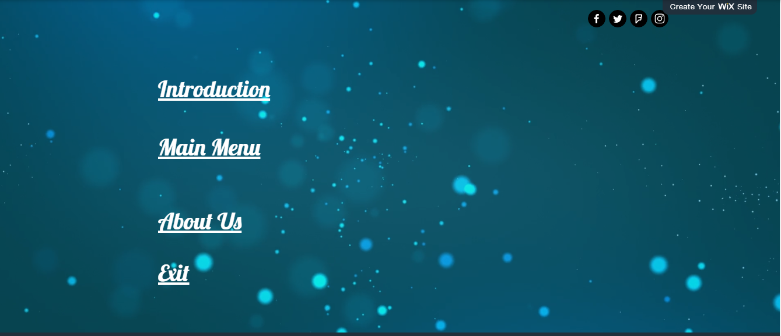

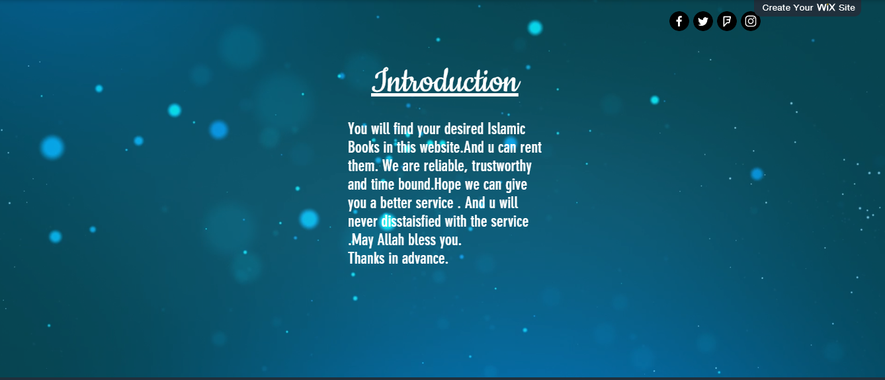 Figure: Snapshot 3

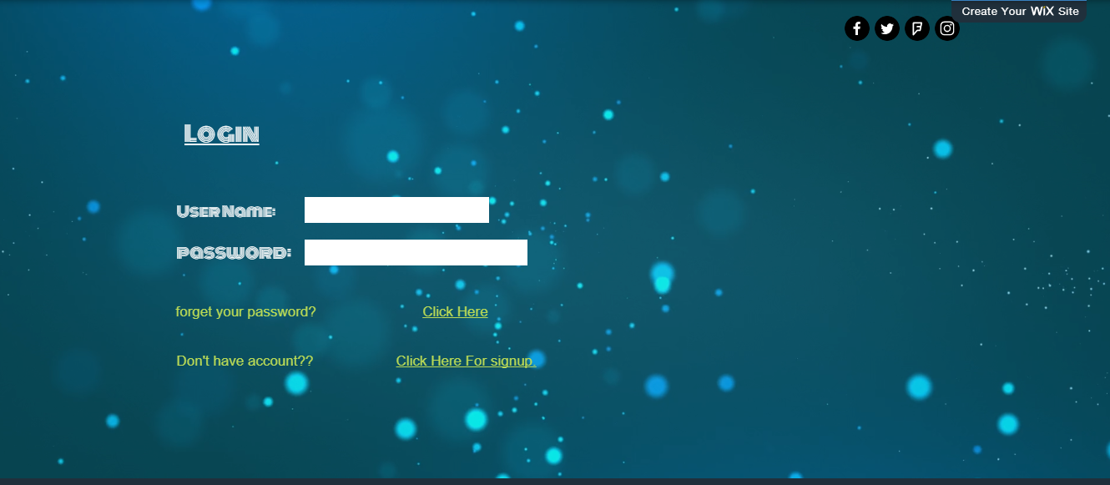

Figure: Snapshot 4

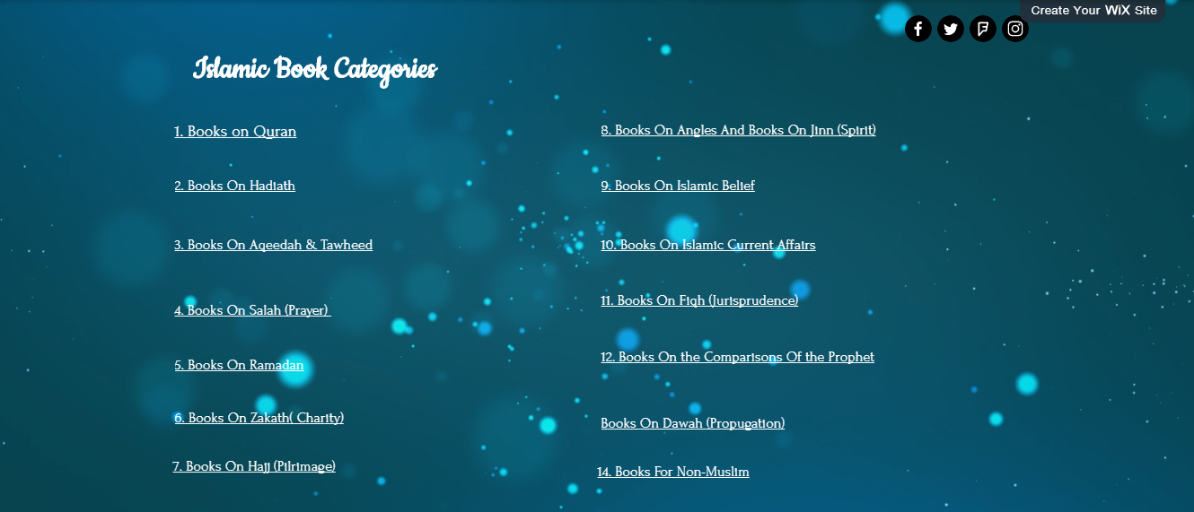

Figure: Snapshot 5

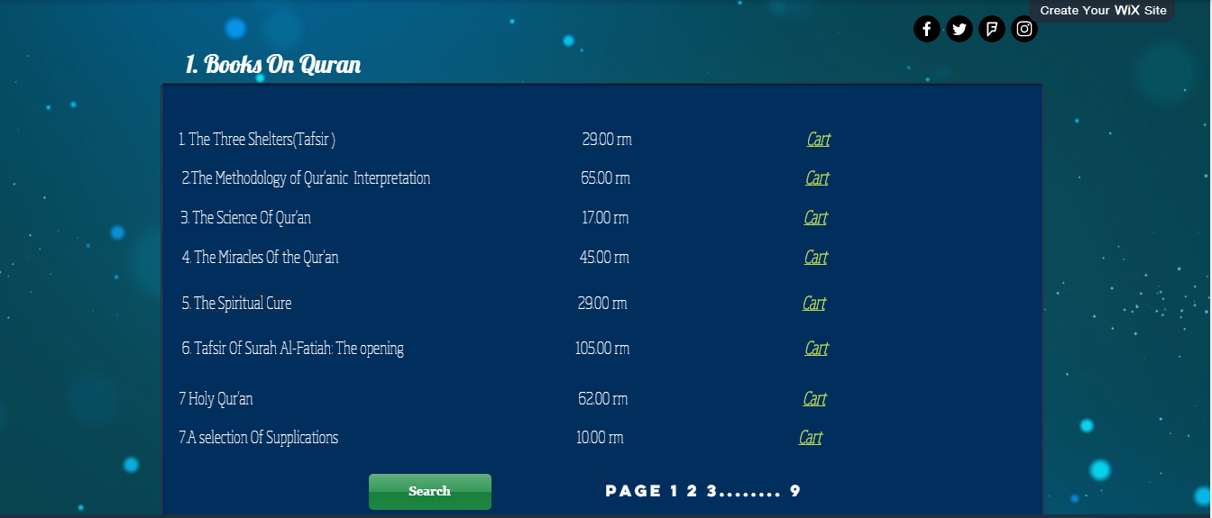

Figure: Snapshot 6

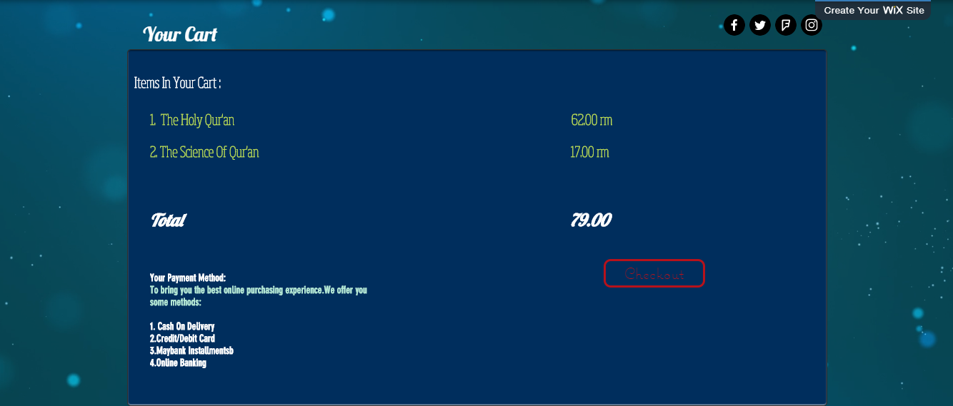

Figure: Snapshot 7

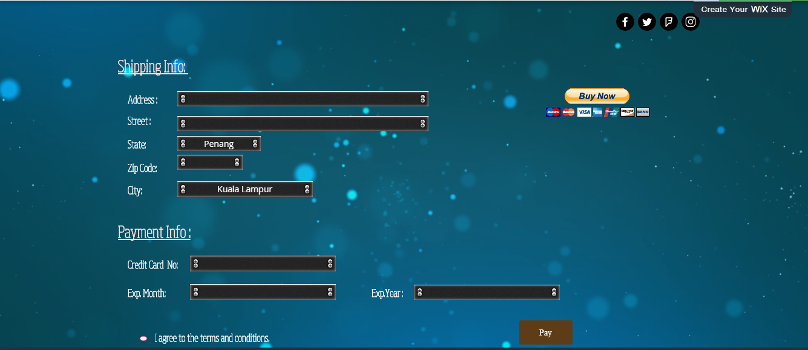

Figure: Snapshot 8

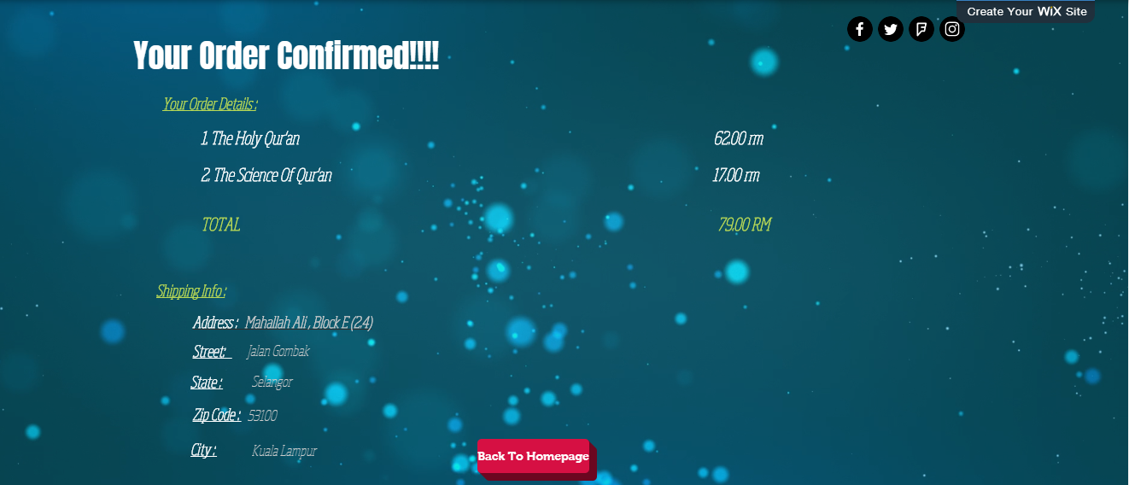

Figure: Snapshot 9

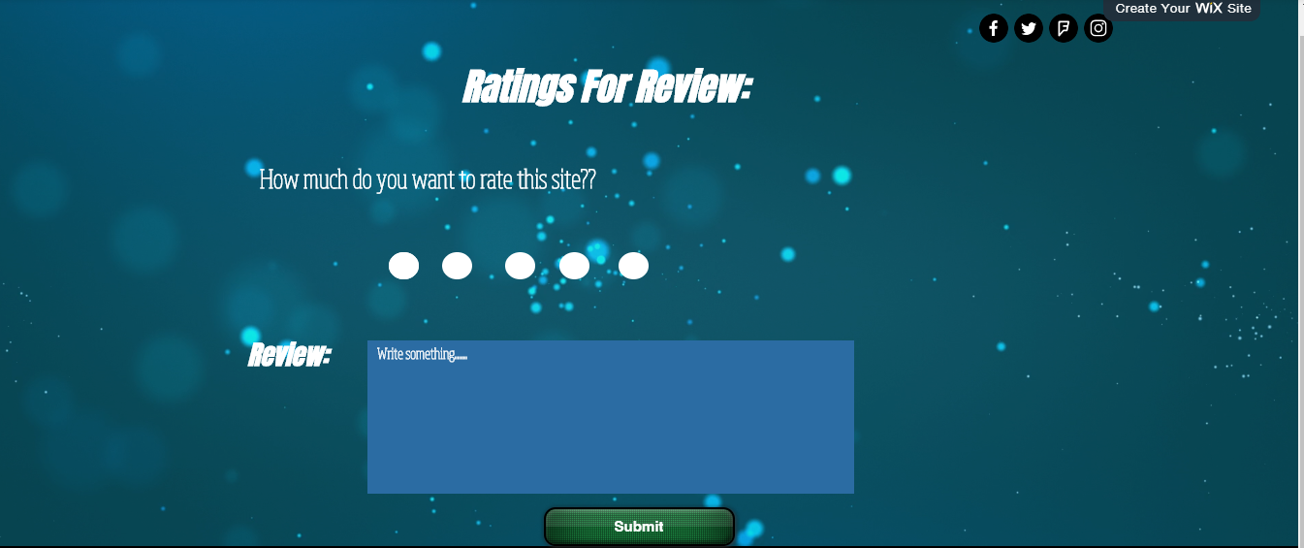

Figure: Snapshot 10



Figure: Snapshot 11

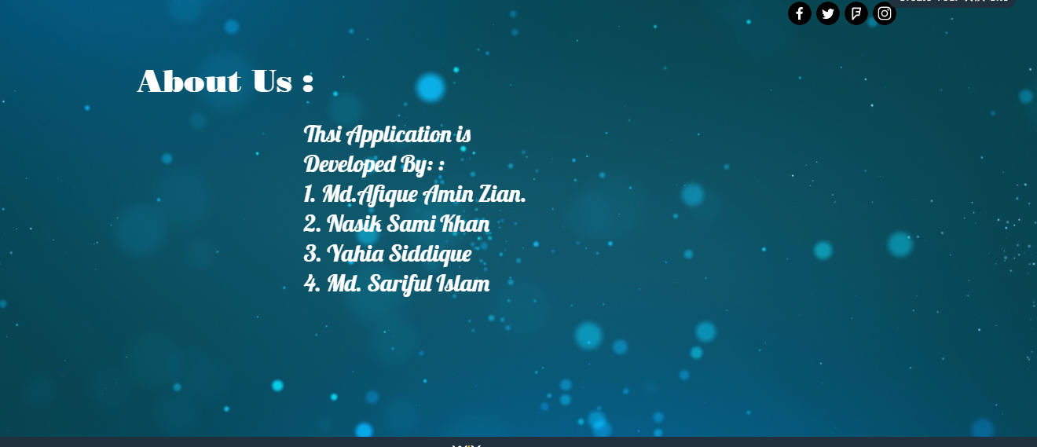

Figure: Snapshot 12

# 5. Testing Phase

**6.1 :Testing Activities:**

To verify valid user who wants to login into the application or system

## Description

|  |  |
| --- | --- |
| **Test Case Description** | |
| **Test Case ID:** FM-0111 | **Test Designed by:** Zian |
| **Test Priority (Low/Medium/High):** Medium | **Test Designed date:** 17/11/17 |
| **Module Name: Online Islamic Book** **Rental System** login screen | **Test Executed by:** Imam sir |
| **Test Title:** Verify login with valid username and password | **Test Execution date:** 24/11/2017 |
| **Description:** Test the **Online Islamic Book** **Rental System** login page |  |
| **Technique used:** Equivalence partitioning – valid partition | |

## 6.2 Precondition

* The user should have a valid account by signing up to the system using a valid email address.
* The user should have a unique and valid username and password.
* System administrator will send an **email** for confirmation to verify the account.

## 6.3 Post Conditions

* The user is valid to login into the application.
* The user can apply any order in the application.

## 6.4 Flow of Events

|  |  |  |  |  |  |  |
| --- | --- | --- | --- | --- | --- | --- |
| **Step** | **Test Steps** | **Test Data** | **Expected Result** | **Actual Result** | **Status**  **(Pass/**  **Fail)** | **Notes** |
| 1 | Navigate to login page | Using mobile phone or desktop to login into the application | User should be able to see the home page of the application or system which displays the login page | User is able to see the home page of the application which displays the login page | Pass | User must have connection to the internet |
| 2 | Provide valid username | User = waelqadah  @gmail.com | User should be able to proceed to login into the application | User should be able to proceed to login into the application | Pass | User must use a valid username which has been  register with valid email address |
| 3 | Provide valid password | Password:  Wael54215421 | User should be able to proceed to login into the application | User should be able to proceed to login into the application | Pass | User must use valid password |
| 4 | Click on Login  button |  | User should be able to login | User is navigated to dashboard with successful login | Pass | The user can apply any job in the application  . |

## 6.5 Special Requirements

* Should login first before using the system.
* Each user should only have one account only.
* Each user has to sign up if they don’t have any account and they should log in using their unique ID and password.
* User cannot have multiple accounts.

# Test Case [FM-0012] for [invalid username or password]

To verify **invalid** user who wants to login into the application.

## 6.5.1 Description

|  |  |
| --- | --- |
| **Test Case Description** | |
| **Test Case ID:** FM-0012 | **Test Designed by:** Nasik Sami |
| **Test Priority (Low/Medium/High):** Medium | **Test Designed date:** 17/11/2017 |
| **Module Name:** Online Islamic Book Rental System login screen | **Test Executed by: Imam** |
| **Test Title:** Verify login with invalid username and password | **Test Execution date:** 23/11/2017 |
| **Description:** Test the Application login page |  |
| **Technique used:** Equivalence partitioning – invalid partition | |

## 6.5.2 Preconditions

* The user should have a valid account by signing up to the system using a valid email address.
* The user should have a unique and valid username and password.
* System administrator will send an email for confirmation to verify the account.

## 6.5.3 Post Conditions

* The user is invalid to login into the application.
* The user cannot apply any job in the application unless he/she logins with a valid account.

## 6.5.4 Flow of Events

|  |  |  |  |  |  |  |
| --- | --- | --- | --- | --- | --- | --- |
| **Ste p** | **Test Steps** | **Test Data** | **Expected Result** | **Actual Result** | **Status**  **(Pass/**  **Fail)** | **Notes** |
| 1 | Navigate to login page | Using mobile phone or desktop to login into the application | User should be able to see the home page of the application which displays the login page | User is able to see the home page of the application which displays the login page | Pass | User must have connection to the internet |
| 2 | Provide valid username | User =  waelq@gmail.com | User should be  able to proceed to login into the application | User should be  able to proceed to login into the application | Pass | User must use a valid username which has been  register with valid email address |
| 3 | Provide an invalid password | Password:  123456 | User should be  able to proceed to login into the application | User should be **unab**le to proceed to login into the application | **Fail** | **User must use valid password** |
| 4 | Click on Login button |  | System  displays error  “invalid  password” | User is navigated to dashboard to login again | Pass | The user must login into the application again with valid  username and password |

## 2.5 Special Requirements

* Should login first before using the system.
* Each user should only have one account only.
* Each user has to sign up if they don’t have any account and they should log in using their unique ID and password.
* User cannot have multiple accounts.

# Test Case [FM-0014] for [invalid username or password]

To verify searching books Page we have to do this test here.

## Description

|  |  |
| --- | --- |
| **Test Case Description** | |
| **Test Case ID:** FM-0014 | **Test Designed by:** Afique Zian |
| **Test Priority (Low/Medium/High):** Medium | **Test Designed date:** 12/11/2017 |
| **Module Name: Search Books page** | **Test Executed by: Imam sir** |
| **Test Title:** Verify searching books page. | **Test Execution date:** 23/11/2017 |
| **Description:** the system will lead us to the searching books page |  |
| **Technique used:** Equivalence partitioning – invalid partition | |

## Preconditions

* The user should click on the button.

## Flow of Events

|  |  |  |  |  |  |  |
| --- | --- | --- | --- | --- | --- | --- |
| **Ste p** | **Test Steps** | **Test Data** | **Expected Result** | **Actual Result** | **Status**  **(Pass/**  **Fail)** | **Notes** |
| 1 | Navigate to login page | Using mobile phone or desktop to login into the application | User should be able to see the home page of the application which displays the login page | User is able to see the home page of the application which displays the login page | Pass | User must have connection to the internet |
| 2 | Click On search Books | Click On search books. | User should be  able to proceed to searching books page | User is now in searching books page | Pass |  |
| 3 | Search a books | User will type a book name | User should be  able to proceed to that particular book page | User is now in that books description page | **Pass** |  |

**Post Conditions:**

1. User is to the page searching for books .

# Implementation Phase

## :Implementation activities

For developing the prototype of our application, we have used **WIX.COM** software. It is a multimedia software platform used for production of animations, rich Internet applications, desktop applications, mobile applications and mobile games. Feature 1 snapshot 1

**Figure 1: Home page of Online Islamic Books Rental**



The above figure is the main screen of our app. There are 1 button.

**Welcome button:** It is the button to enter the Home page.

### 7.1.2 Feature 1 snapshot 2 :



**Figure 2: Main Menu Page**The above figure is the interface for general users. There are 4 buttons.

1. **Introduction: About the application.**
2. **Main Menu.**
3. **About us: About the developers.**
4. **Exit**

**7.1.3 Feature 1 snapshot 3:**



**Figure 3: Introduction Part**

**Figure 3:** Shows the details introduction about our website, what can people search here and how to get the books.

**7.1.4 Feature 1 snapshot 4:**



**Figure 4: Login Page**

**Figure 4:** From this login page you have to go through with your valid username and password. To enter to the book catagories.

**7.1.4 Feature 1 snapshot 5:**



**Figure 5**: Islamic book catagories

**Figure 5**: This page will show you the book catagories of Islamic Books. You can select from here the desied books.

**7.1.4 Feature 1 snapshot 6:**



**Figure 6: Specific books of specific catgories.**

**Figure 6:** This snapshot will show you the specific books of different

categories. You can then cart them for renting.

**7.1.4 Feature 1 snapshot 7:**



**Figure 7: Your Cart**

**Figure 7: will show you your carted books which you want to**

**You will then checkout again if you want to add or delete**

**something.**

**7.1.4 Feature 1 snapshot 8:**



**Figure 8: shipping info**

**Figure 8: You will have to give your proper address here and also complete**

**the payment method.**

**7.1.4 Feature 1 snapshot 9:**



**Figure 9: Confirmation of your order.**

**Figure 9**: It will show you your address and total paid money for your

confirmation .

**7.1.7 Feature 1 snapshot 10:**



**Figure 10: The Review Option.**

**Figure 10:** depends on your website people can review your website in

this Figure 10.

**7.1.7 Feature 1 snapshot 11:**



**Figure 11: Thanking page**

**Figure 11: we design this page to give a thanks to our customer who rent   
 books from us**

**7.1.7 Feature 1 snapshot 12:**



**Figure 12: About us**

**Figure 12:** This is the last page of our website. And this page will show you the

Persons who developed this website.

**Link of the Youtube prototype video:**

**https://www.youtube.com/watch?v=B2nE_ipyJq8&feature=youtu.be**

**APPENDIX**

https://en.wikipedia.org/wiki/Requirements_engineering

**Thank You**